A study of the correlation between incoming calls
# Initial data
The basis for the study was the eGain Dialed Number Summary Report, which provides data by day and phone number on the number of incoming calls, offered to / queued / not queued calls, and abandoned calls.
The question arises - is there some direct correlation between the number of calls, and if so - with what probability can this correlation be predicted?
# Exploring the relationships in the data
Pairwise plots can help notice data relationships in the dataset:
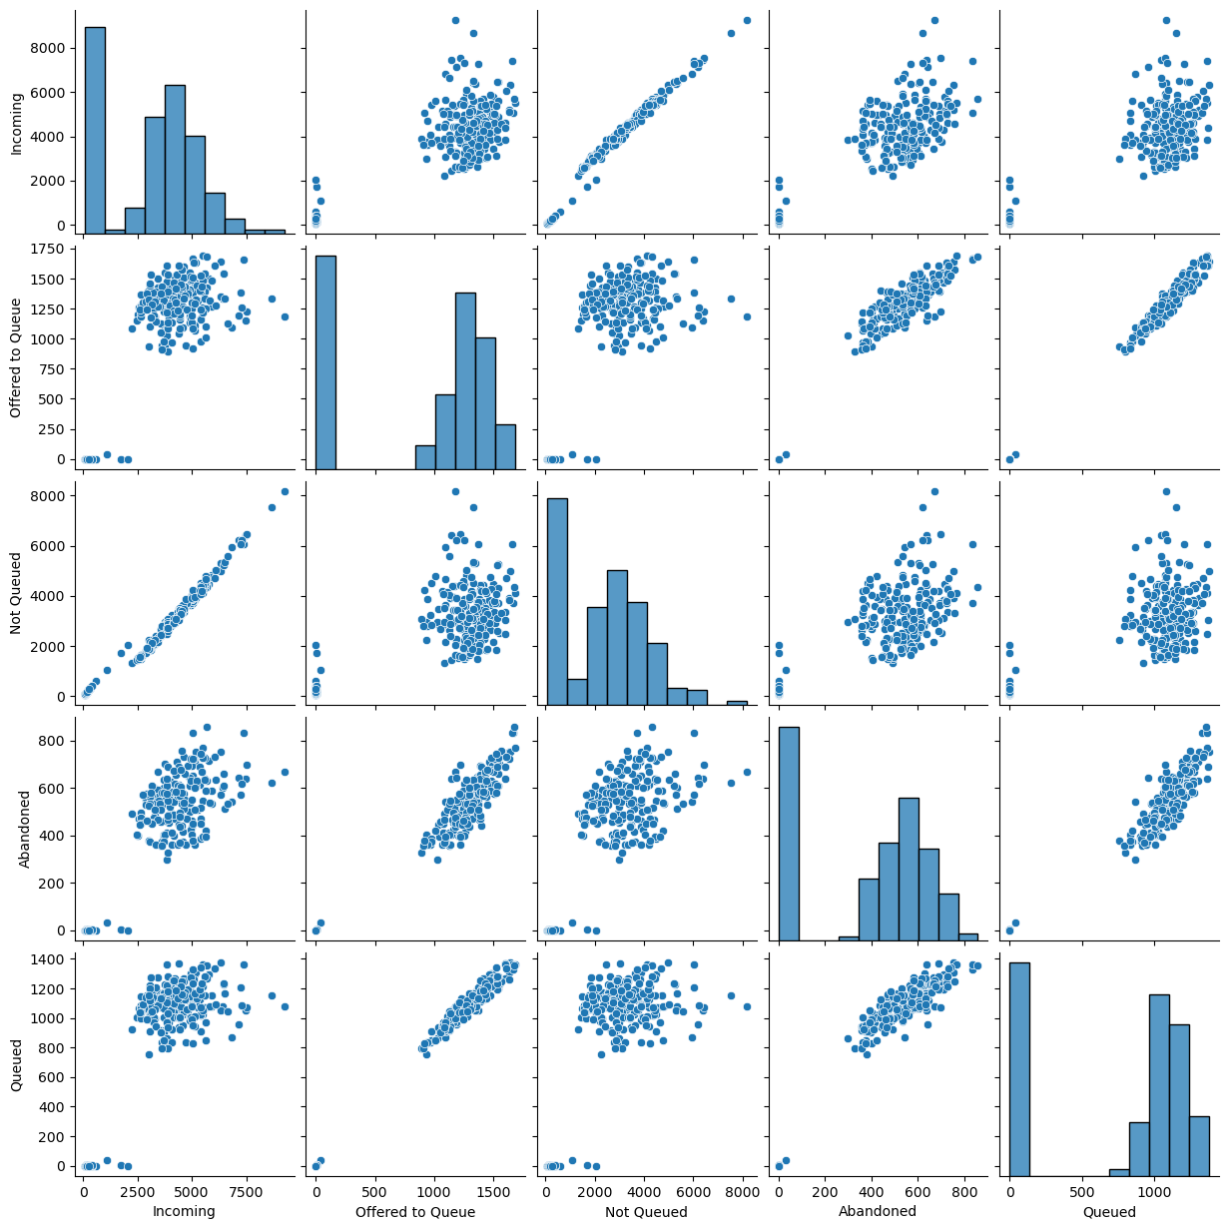
In these graphs, the histograms of the distribution of features in the dataset are plotted along the diagonal, and the remaining cells are plots of the relationships between the different features in the dataset.
Some distributions are quite similar to linear dependence and, most likely, can directly correlate with each other. Various machine learning methods can build a model of such dependence. Next, we will consider one of the simplest methods - the method of least squares for linear regression - on the example of analyzing the dependence of abandoned and queued calls:
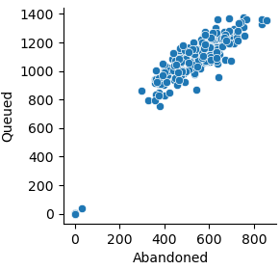
# Abandoned & Queued Calls
If you analyze the data for 2023, you can see that the number of abandoned calls is always about half the number of queued calls:
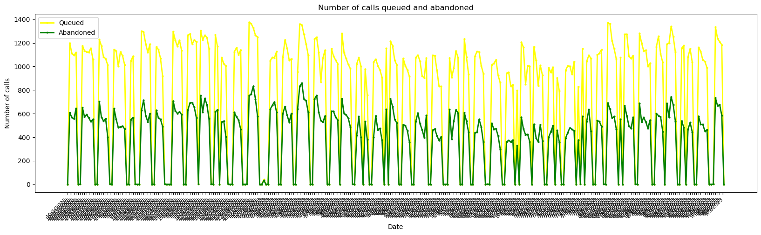
Averaged over all days and phone numbers, the number of queued calls: 250.
Averaged over all days and phone numbers, the number of abandoned calls: 125.
Let's try to establish a more precise relationship between abandoned and queued calls using the linear regression model constructed, and then estimate the resulting relationship on the available 2024 data.
# Data Model Results
After summarizing the number of calls by day and building a linear regression model, we can interpret and estimate it. One of the indicators of model accuracy is R-squared, which tells us how much variation in Abandoned Calls Number is explained by the model. An R-squared of 0.969 is fairly high, and this means that 96.9% of the variation in Abandoned Calls Number is explained by the model:
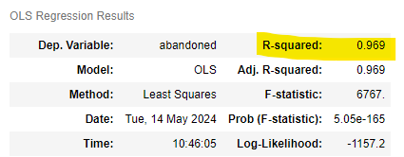
Linear regression interprets the relationship between features as a linear function:
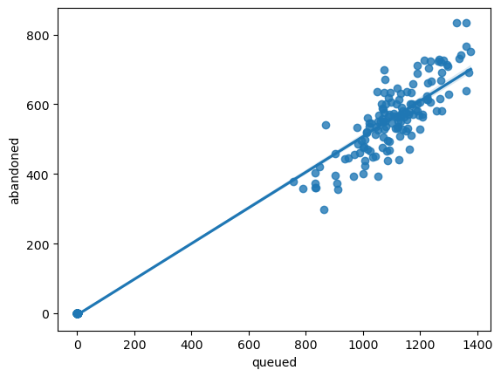
It gives the equation of this relationship:
abandoned = queued * 0.5119 - 4.4718
And statistical probability of data deviation from this approximation. In this case, with 95% probability the model states that the average number of abandoned calls will lie in the range:
from queued * 0.500 - 15.587 to queued * 0.524 + 6.643
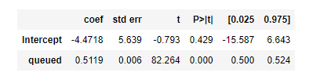
# Model Checking
Taking the available data for 2024, let's try to test the performance of the model built on 2023 data.
Averaged over all days and phone numbers, the number of queued calls: 296.
Substituting this value into the above formulas, we can calculate that the average number of abandoned calls should be estimated at 147 and with 95% probability fall within the range of 132 to 161.
In fact, the report shows the average number of abandoned calls: 140.
The graph plotted on the 2024 data shows the following distribution (the red line shows the straight line predicted by the model; the yellow dashed line shows the boundaries of the model's probability distribution):
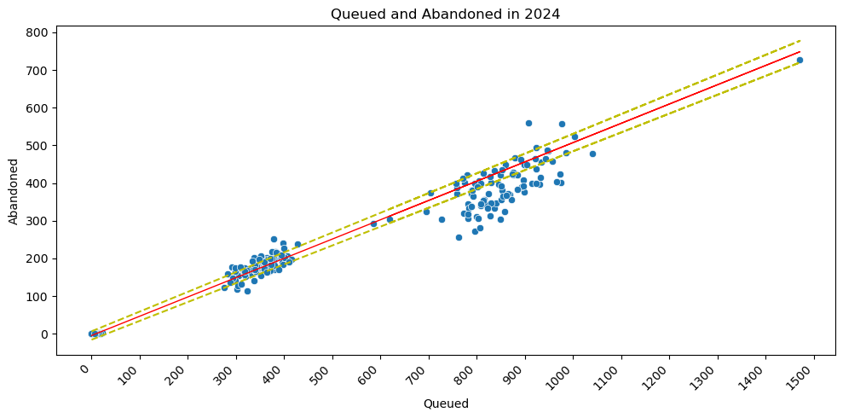
Thus, the built machine learning model seems to be quite workable and can be used to estimate the studied dependence in the future. Of course, this example shows the simplest linear dependence of one parameter on another, and if the business model changes (e.g., changing the conditions for queuing calls), it may no longer be adequate.
# Model Validation
Linear regression model has certain limitations for use: independence of observations, normality of residuals distribution, heteroskedasticity. These limitations must always be taken into account, and this is the other side of the coin of any machine learning model. Below are plots of residuals distribution for this model, indicating that its quality is quite high:
